Ex: -1.Star Topologies using Packet Tracer.

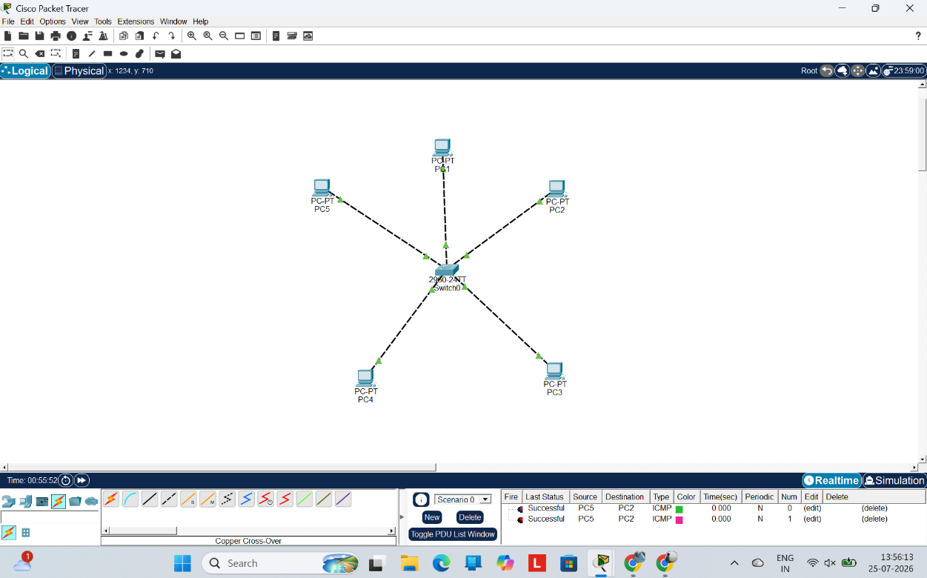

EX:2 Design and Configuration of BUS Topologies using Packet Tracer.

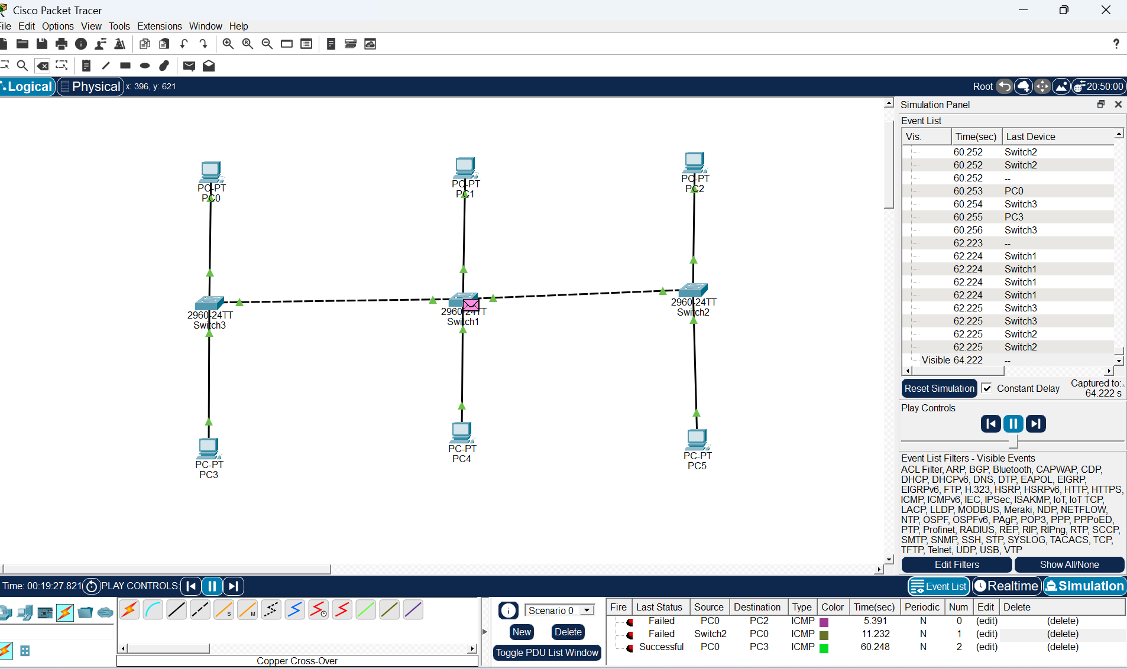
EX:3 Design and Configuration of RING Topologies using Packet Tracer.

